
Viewed by:
Philippe POHER
Tel.: +33 (0)2 99 27 92 92
E-mail: philippe.poher@iwedia.com

Written by:
Fabien DUTERTRE
Tel.: +33 (0)2 99 27 92 92
E-mail:fabien.dutertre@iwedia.com
IWEDIA

TDAL_VBI Technical Specifications

V2.0

Approved by:
Thierry GARNIER
Tel.: +33 (0)2 99 27 92 92
E-mail: thierry.garnier@iwedia.com

SUMMARY
1 Reference documents 3
2 Documentation History 4
3 Introduction 5
4 Module Overview and Architecture 6
4.1 Definitions, Acronyms and Abbreviations 6
4.2 General Description 6
4.2.1 VBI 6
4.2.2 WSS 6
4.3 Architecture 7
4.4 TDAL_VBI API Description 8
4.4.1 Generic Interface 8
5 TDAL_VBI API Specification 9
5.1 Type Specifications 9
5.1.1 Generic 9
5.1.2 Interaction 9
5.2 TDAL_VBI API Usage 10
5.2.1 Start the teletext insertion on a Channel and Stop it 10
5.2.2 Start the WSS insertion on a Channel 11
5.3 TDAL_VBI Macro/Define/Enum/Typedef/Structure Definitions 12
5.3.1 Define Definitions 12
5.3.2 Enum Definitions 12
5.3.2.1 tTDAL_VBI_Error 12
5.3.2.2 tTDAL_VBI_Types 12
5.3.2.3 tTDAL_VBI_WssAspectRatio 12
5.4 TDAL_VBI API Functions 13
5.4.1 TDAL_VBI_Init(-) 13
5.4.2 TDAL_VBI_Terminate(-) 14
5.4.3 TDAL_VBI_APIRevisionGet(-) 15
5.4.4 TDAL_VBI_PlatformRevisionGet(-) 16
5.4.5 TDAL_VBI_Open(-) 17
5.4.6 TDAL_VBI_Close(-) 18
5.4.7 TDAL_VBI_Start(-) 19
5.4.8 TDAL_VBI_Stop(-) 20
5.4.9 TDAL_VBI_SetWSSAspectRatio(-) 21

Reference documents
The following documents were used to write this specification:

Document | Version | Title

Documentation History

History
Vers. | Date | Nature
1.0 | 02/04/2004 | Initial Version
1.1 | 24/12/2004 | Add VBI_Open and VBI_Close & change functions prototype
2.0 | 10/01/08 | Editorial review

Introduction
The purpose of this document is to specify the interface and to describe the internal design of the Thin Driver Adaptation Layer Vertical Blanking Insertion [TDAL_VBI]. The aim of this module is to allow to a client module to start and stop the Teletext insertion (VBI), and to insert the WSS (WideScreen Signaling) aspect ratio.

Module Overview and Architecture

Definitions, Acronyms and Abbreviations
API | Application Programmer’s Interface
STB | Set Top BOX
VBI | Vertical Blanking Insertion
WSS | WideScreen Signaling

General Description
The main job of the TDAL_VBI is to start or stop the Teletext insertion in the signal to the TV.
Some general descriptions need first to be done.

VBI
The vertical blanking interval (VBI), also known as the vertical interval or VBLANK, is the time interval between the end of the last line of one frame and the beginning of the next. It is present in analog television. During the VBI the incoming data stream is not displayed on the screen. In cathode ray tubes the beam is blanked to avoid displaying the retrace line.
In analog television systems the vertical blanking interval can be used to carry digital data, since nothing sent during the VBI is displayed on the screen; various test signals, time codes, closed captioning, teletext, and other digital data can be sent during this time period.
So, the teletext is a broadcasting service that transmits text to a TV set that has a teletext decoder. It uses the vertical blanking interval of the TV signal to transmit about a hundred frames.

WSS
In telivision technology, the WSS is a digital stream embedded in the TV signal describing qualities of the broadcast, in particular the intended aspect ratio of the image. This can be used by a widescreen TV to switch to the correct display mode.

Architecture
The figure below shows the relation between the client module and the low level drivers:

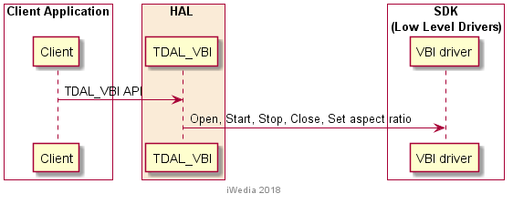

TDAL_VBI API Description

Generic Interface
The generic interface allows clients to control the TDAL_VBI module.
This interface is used with the following functions:
- TDAL_VBI_Init(-) in order to initialize the TDAL_VBI module.
- TDAL_VBI_Terminate(-) in order to terminate the TDAL_VBI module.
- TDAL_VBI_APIRevisonGet(-) in order to retrieves the API revision.
- TDAL_VBI_PlatformRevisonGet(-) in order to retrieves the platform implementation revision.
- TDAL_VBI_Open(-) in order to proper initialise a teletext or Wss instance.
- TDAL_VBI_Close(-) in order to close a teletext or Wss instance..
- TDAL_VBI_Start(-) in order to start the teletext insertion.
- TDAL_VBI_Stop (-) in order to stop the current teletext insertion.
- TDAL_VBI_SetWSSAspectRatio(-) in order to send the WSS value for the aspect ratio.

TDAL_VBI API Specification

Type Specifications

Generic
tTDAL_VBI_Error defines error values detected by tdal_vbi functions.
tTDAL_VBI_Type is used to define VBI instance identifier (teletext or WSS).
tTDAL_VBI_WssAspectRatio is used to give the aspect ration.

Interaction
The Teletext datas to insert aren’t given by the application. The module TDAL_VBI used the module TDAL_DMX to get the information needeed by the VBI (pid teletext)

TDAL_VBI API Usage

Start the teletext insertion on a Channel and Stop it
The initialisation of TDAL_VBI API is made. The type of the driver is then given and the start is done.

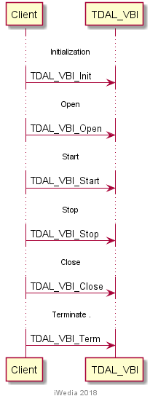

Start the WSS insertion on a Channel
The initialisation of TDAL_VBI API is made. The type of the driver is then given and the value of WSS is sent.

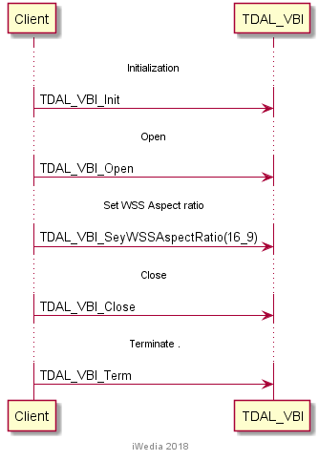

TDAL_VBI Macro/Define/Enum/Typedef/Structure Definitions

Define Definitions
None

Enum Definitions

tTDAL_VBI_Error
An enumeration of the different possible error returned by TDAL_VBI.
typedef enum
{
eTDAL_VBI_NO_ERROR = 0, /* No Error returned */
eTDAL_VBI_NOT_DONE, /* Not implemented */
eTDAL_VBI_BAD_DEMODULATOR, /* Bad parameter given to the function */
eTDAL_VBI_ERROR /* Problem occurs in low level driver */
} tTDAL_VBI_Error;

tTDAL_VBI_Types
An enumeration of the differents types supprted by TDAL_VBI.
typedef enum
{
eTDAL_VBI_TELETEXT,
eTDAL_VBI_WSS
}tTDAL_VBI_Type;

tTDAL_VBI_WssAspectRatio
An enumeration of the differents Aspect ration supprted by TDAL_VBI.
typedef enum
{
eTDAL_VBI_14_9_FULL_FORMAT, /* Full Format 4:3 (Shoot&Protect 14:9 center) */
eTDAL_VBI_14_9_LETTERBOX_CENTER,
eTDAL_VBI_14_9_LETTERBOX_TOP,
eTDAL_VBI_16_9_FULL_FORMAT,
eTDAL_VBI_16_9_LETTERBOX_CENTER,
eTDAL_VBI_16_9_LETTERBOX_TOP,
eTDAL_VBI_4_3_FULL_FORMAT,
eTDAL_VBI_HIGHER_THAN_16_9_LETTERBOX_CENTER
} tTDAL_VBI_WssAspectRatio;

TDAL_VBI API Functions

TDAL_VBI_Init(-)
Prototype:
tTDAL_VBI_Error TDAL_VBI_Init ( void );
Description:
This function initialises the VBI decoder drivers.
Return value:
It returns eTDAL_VBI_NO_ERROR if initialisation succeeds or eTDAL_VBI_ERROR, otherwise.
Parameters:
Nones
Comments:
This function must be called before any other functions of the TDAL_VBI API.
See Also:
TDAL_VBI_Terminate(-).

TDAL_VBI_Terminate(-)
Prototype:
tTDAL_VBI_Error TDAL_VBI_Terminate (uint8_t ucFeID);
Description:
This function terminates the TDAL_VBI module.
Return value:
It returns eTDAL_VBI_NO_ERROR if termination succeed.
It could be eTDAL_VBI_ERROR otherwise.
Parameters:
None
Comments:
Any function of TDAL_VBI API should not be called after TDAL_VBI_Terminate(-) call.
See Also:
TDAL_VBI_Init(-).

TDAL_VBI_APIRevisionGet(-)
Prototype:
Cont char *TDAL_VBI_APIRevisionGet(void);
Description:
This function retrieves the API revision.
Return value:
A string containing the revision of the TDAL_VBI API.
Parameters:
None.
Comments:
This function can be called at any time.
See Also:

TDAL_VBI_PlatformRevisionGet(-)
Prototype:
Const char *TDAL_VBI_PlatformRevisionGet(void);
Description:
This function retrieves the platform implementation revision.
Return value:
A string containing the revision of the TDAL_VBI implementation on a platform.
Parameters:
None.
Comments:
This function can be called at any time.
See Also:

TDAL_VBI_Open(-)
Prototype:
tTDAL_VBI_Error TDAL_VBI_Open
(
tTDAL_VBI_Type VBI_Type
);
Description:
This function configures the low level drivers for the type of VBI asked.
Return value:
It returns eTDAL_VBI_BAD_PARAMETER if VBI_Type does not exist, eTDAL_VBI_ERROR otherwise.
Parameters:
Parameter | Type | Dir | Description
VBI_Type | tTDAL_VBI_Type | In | VBI type
Comments:
This function can be called at any time the TDAL_VBI has been initialised with TDAL_VBI_Init(-) but not after the termination with TDAL_VBI_Terminate(-).
See Also:
tTDAL_VBI_Types

TDAL_VBI_Close(-)
Prototype:
tTDAL_VBI_Error TDAL_VBI_Close
(
tTDAL_VBI_Type VBI_Type
);
Description:
This function closes the low level drivers. It depends on the type of VBI.
Return value:
It returns eTDAL_VBI_BAD_PARAMETER if VBI_Type does not exist, eTDAL_VBI_ERROR otherwise.
Parameters:
Parameter | Type | Dir | Description
VBI_Type | tTDAL_VBI_Type | In | VBI type
Comments:
This function must be called after the TDAL_VBI_Open() with the same VBI_Type.
See Also:
tTDAL_VBI_Types
TDAL_VBI_Open(-)

TDAL_VBI_Start(-)
Prototype:
tTDAL_VBI_Error TDAL_VBI_Start( void );
Description:
This function starts the teletext insertion.
Return value:
It returns eTDAL_VBI_NO_ERROR if succeeds or eTDAL_VBI_ERROR, otherwise.
Parameters:
None
Comments:
This function must be called after the TDAL_VBI_Open() with the VBI_Type eTDAL_VBI_TELETEXT.
See Also:
TDAL_VBI_Open(-)

TDAL_VBI_Stop(-)
Prototype:
tTDAL_VBI_Error TDAL_VBI_Stop( void );
Description:
This function stops the teletext insertion.
Return value:
It returns eTDAL_VBI_NO_ERROR if succeeds or eTDAL_VBI_ERROR, otherwise.
Parameters:
None
Comments:
This function must be called after the TDAL_VBI_Start().

TDAL_VBI_SetWSSAspectRatio(-)
Prototype:
tTDAL_VBI_Error TDAL_VBI_Close
(
tTDAL_VBI_WssAspectRatio WssAspectRatio
);
Description:
This function generates the WSS value for the aspect ratio.
Return value:
It returns eTDAL_VBI_BAD_PARAMETER if WssAspectRatio does not exist, eTDAL_VBI_ERROR otherwise.
Parameters:
Parameter | Type | Dir | Description
WssAspectRatio | tTDAL_VBI_WssAspectRatio | In | WSS format
Comments:
This function must be called after the TDAL_VBI_Open() with the VBI_Type eTDAL_VBI_WSS.
See Also:
tTDAL_VBI_WssAspectRatio
TDAL_VBI_Open(-)

